Aligarh Muslim University
Department of Computer Science

LAB FILE


Submitted By:
Name: Sumaniya Sheikh
Enrolment Number: GR0960
Faculty Number: 25CAMSA144
Subject Code: CAMS3P01
Subject Name: Laboratory Course -III

Submitted To:
Dr. Faisal Anwer
Dr. Faraz Masood
Mr. Saad Shamim
Mr. Ahsan Shameem

Week #1
- Write a program to find the product of two user-supplied integers and if the product is equal to or lower than 5000, then return the sum of the two numbers.

Solution:
num1,num2= int(input("enter a number = ")),int(input("enter a number = "));
print(num1+num2 if num1*num2<=5000 else prod)
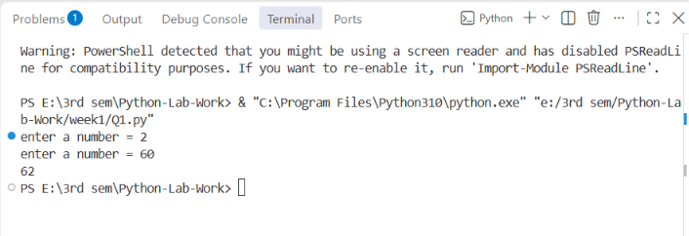

- Write a program to print the sum of the first 10 numbers

Solution:
for i in range(1, 11):
sum=sum+i
print(sum)
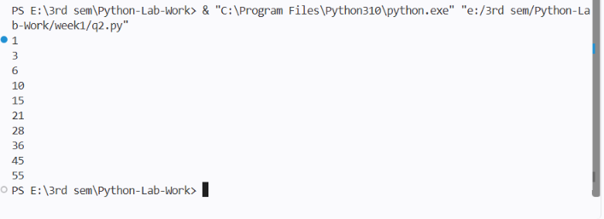

- Write a program to iterate through a supplied list of 20 numbers and print only those numbers which are divisible by 5.

Solution:
num=[1,2,3,4,5,6,7,8,9,10,11,12,13,14,30,24,34,32,27,35]
for i in num:
if i%5==0:
print(i)
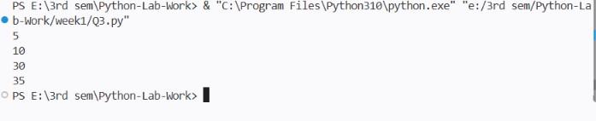

- Write a program to check if the given number is a palindrome.

Solution:
num=(input("enter a number = "))
if str(num)==str(num)[::-1]:
print("palindrome")
else:
print("not palindrome")
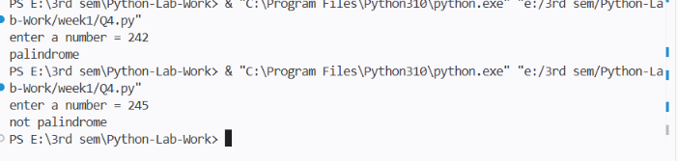
- Write a program to calculate the cube of all numbers from 1 to a given number.

Solution:

num=int(input("enter a three digit number = "))
for i in range(1, num):
cube=i*i*i
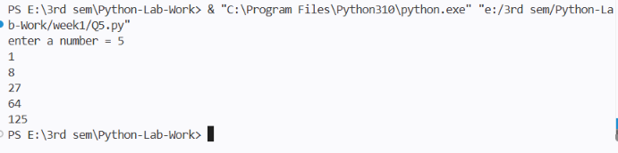
print(cube)

Week #2
- Write a program to extract each digit from an integer in reverse order.

Solution:
num=int(input("enter number = "))
while num>0:
digit= num%10
print(digit)
num=num//10
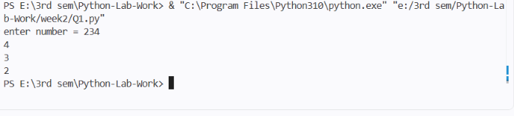
- Write a program to count the total number of digits in a number using a while loop.

Solution:
num=int(input("enter number = "))
count=0
while num>0:
digit= num%10
count=count+1
num=num//10

print("Total number of digits = ", count)

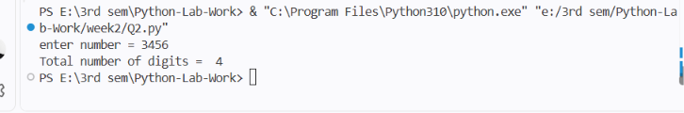
- Write a program to display all prime numbers within a range.

Solution:
start=int(input("enter the starting number = "))
end=int(input("enter the end range = "))
for num in range(start, end+1):
if num<2:
continue
is_prime =True
for i in range(2, int(num ** 0.5)+1):
if num%i==0:
is_prime=False
break
if is_prime:
print(num)
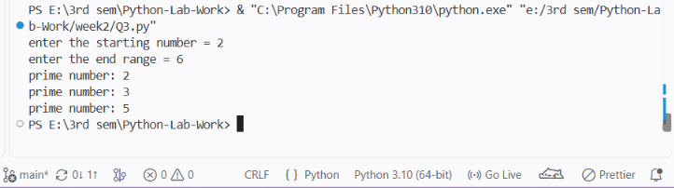

- Write a program to use a loop to find the factorial of a given number.

Solution:
from functools import reduce;
n=int(input("enter a number = ")); fact=(reduce(lambda x,y: x*y, range(1,n+1),1))
print(fact)
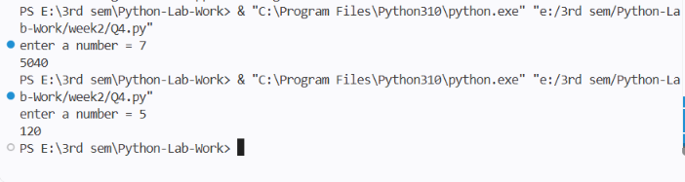
- Write a program to find the sum of the digits of a supplied integer.

Solution:
sum=sum(map(int,input("enter a integer = ")))
print("sum of the digits of a supplied integer = ",sum)

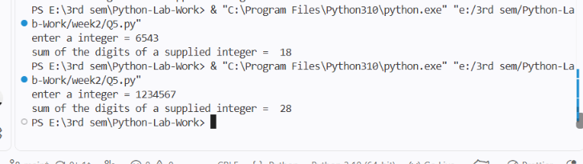

Week #3
- Write a program to print the following pattern using the for loop:
5 4 3 2 1
4 3 2 1
3 2 1
2 1
1

Solution:
# for i in range(5,0,-1):
# for j in range(i,0,-1):
# print(j, end=" ")
# print()

for i in range(5,0,-1):
print(range(i,0,-1))
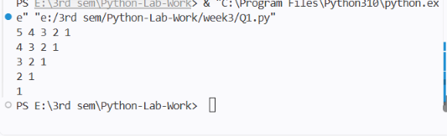

- Write a program to print the following star pattern using the for loop:
*
* *
* * *
* * * *
* * * * *
* * * *
* * *
* *
*
Solution:
for i in range(1, 10):
print()
if i<=5:
for j in range(1, i+1):
print("*", end=" ")
else:
for j in range(10-i):
print("*", end=" ")

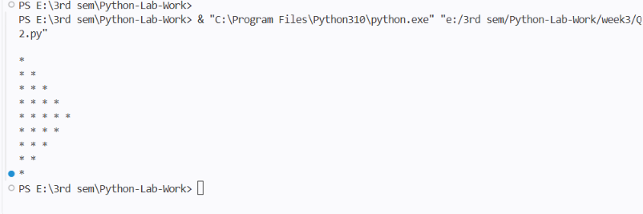

- Write a program to print characters from a string which are present at even index numbers.
Solution:
str="Sumaniya"
for i in range(len(str)):
if i%2==0:
print(str[i])

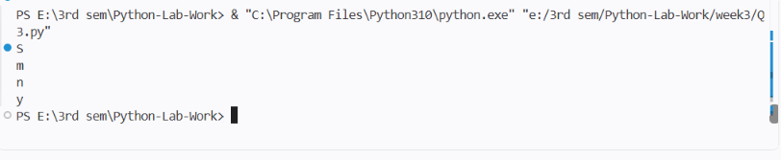
- Write a program to accept a string from the user and display characters that are present at even index numbers.
Solution:
str= input("enter a string = ")
for i in range(len(str)):
if i%2==0:
print(str[i])
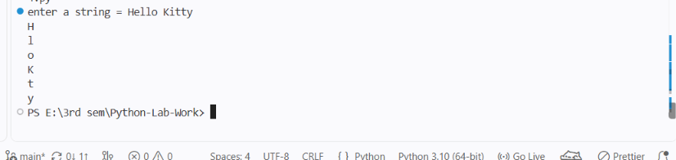

- Write a program to remove characters from a string starting from the nth position to the last and return a new string. Example: remove_chars(”aligarh”, 3) should output ali.

Solution:
def remove_chars(str,num):return str[:num]
str= input("enter a string = ")
num=int(input("enter the position = "))
print(remove_chars(str,num))
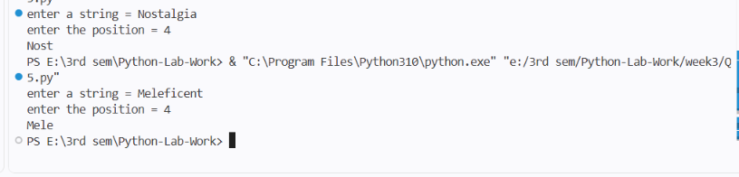
Week #4
- Write a program to create a function cal_sum_sub() that accepts two variables and calculates addition and subtraction. Also, it must return both addition and subtraction in a single return call.

Solution:
def cal_sum_sub(a,b):
return a+b, a-b

a,b = map(int,input("enter first number = ").split())

print(cal_sum_sub(a,b))

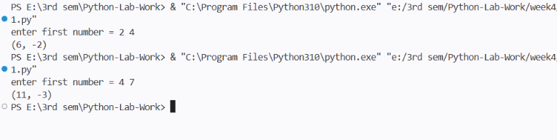

- Write a function to return True if the first and last number of a given list are the same. If the numbers are different, return False.

Solution:
def check_list(lst):
return lst[0]==l[-1]
l= list(map(int,input("enter a list of integer = ").split()))
print(check_list(l))

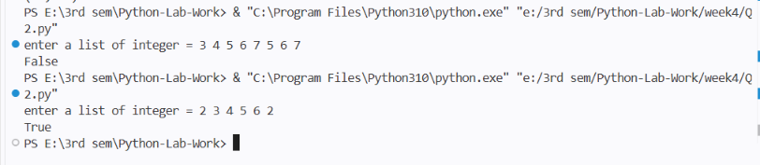
- Given a list of numbers, write a program to turn every item of the list into its square.

Solution:

li= list(map(int,input("enter a list of integer = ").split()))
print(list(map(lambda x:x**2,li)))

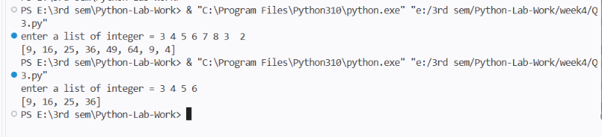

- Given two Python lists, write a program to iterate both lists simultaneously and display items from list1 in original order and items from list 2 in reverse order.

Soultion:

from itertools import zip_longest
l1= [1,2,3,4,5]
l2=[1,2,3,4,5,6,7]
for a,b in zip_longest(l1,reversed(l2),fillvalue=0):
print(a,b)

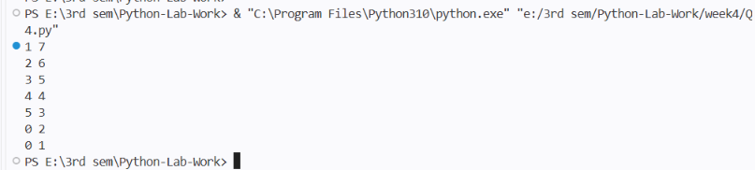
- Write a program to count the number of occurrences of item 50 in the tuple tp1 = (50, 10, 60, 70, 50).

Solution:
tp1=(50,10,60,70,50)
print("tuple = ",tp1)
count=tp1.count(50)
print("number of occurrences = ", count)

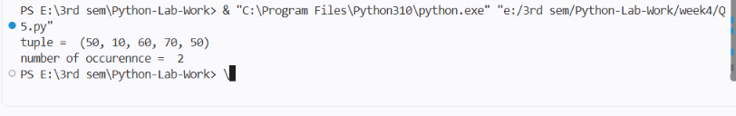

Week #5
- Write a program to generate a 6-digit random secure OTP.

- Write a program to generate a random password that meets the following conditions:
- Password length must be 10 characters long.
- It must contain at least 2 uppercase letters, 1 digit, and 1 special symbol.

- Given two lists of numbers, write a program to create a new list containing odd numbers from the first list and even numbers from the second list.

Solution:
- Write a program to create a numpy array and return an array of odd rows and even columns from the numpy array.

- Write a program to create a numpy array and sort it as per the following cases:
- Case 1: Sort the array by the second row.
- Case 2: Sort the array by the second column.

Week #6
- Write a Python program that inputs two tuples and creates a third that contains all elements of the first followed by all elements of the second.
- Write a Python program to create a dictionary with names and phone numbers. Then ask the user for a name and print the corresponding phone number.
- Write a Python program to calculate the sum of squares of the first two digits and the last two digits of a 4-digit number, e.g., for 1233, calculate 12^2 + 33^2.
- Write a program that inputs a main string and creates an encrypted string by embedding a short symbol-based string after each character. The program should also decrypt the string.
- Write a program to get roll numbers, names, and marks of students and store these details in a file called ”Marks.data”.
- Write a program to accept a string and display:
- Number of uppercase characters.
- Number of lowercase characters.
- Total number of alphabets.
- Number of digits.
- Create a C program that accepts an IPv4 address and subnet mask in dotted decimal format, and outputs:
- Network ID
- Broadcast Address
- First and Last Host Address
- CIDR notation
- Number of valid hosts
- IP Address Class (A/B/C/D/E)

Week #7
- Write a report on different types of Linux shells (sh, csh, ksh, bash).
- Copy, move, and remove files using cp, mv, and rm commands.
- Create and delete directories using mkdir and rmdir.
- Change the current working directory using cd and display the present working directory using pwd.
- Consider two files that contain information about Employees and Departments in the following parameters: Employee (Name, EId, Salary, DID), Department (DID, DName, DLocation). Write a Python program to find the average salary of each department.
- Consider two files having some lines of statements. Write a Python program to swap content present at middle line of first file with the content of last line of the second file. (Note: First file contains odd numbers of lines of statement)
- Simulate a RIP-like behavior using a Python program. Accept a list of directly connected routers with hop counts and simulate RIP updates for 3 rounds. Show how the routing table evolves.

